HERE WE ARE PROJECT AT CAIRNDOW

Report on site visit 15th January 2010; Tom Addyman, Dot Chalmers, Tanja Romankiewicz

1. Introduction

Tom Addyman and Tanja Romankiewicz of Addyman Archaeology undertook an analytical assessment of six buildings within Kilmorich parish at Cairndow, near Inverary, Argyll. The assessment will feed into the Our Homes – Their Stories project, part of the Heritage Lottery funded local history initiative being organised by the Here We Are centre at Cairndow (contacts, Christina Noble, Alice Beattie and Dot Chalmers). The site visit was undertaken on Friday 15th January, 2010.

The purpose of the exercise was to undertake an outline analysis and photographic record of a selected group of properties of varying age, state of preservation and function. The examination of each building involved a written description by Tom Addyman, based upon narration into a dictaphone on site. This test was transcribed, added to and formatted into the present report. A digital photographic record with general shots of each property and significant individual details was undertaken by Tanja Romankiewicz. The images are sent as an accompanying attachment to this report. The site visits were arranged by Dot Chalmers, who also accompanied on the day. By this means many additional details of the community’s history, notes about the occupants of each property and details of the history of the buildings themselves (particularly later modifications) was also recorded.

Note : although the general alignment of the head of Loch Fyne is SW/NE, with the majority of building orientations within the parish naturally respecting this axis, for the practical purposes of the following descriptions this is given as an E/W axis of the loch (thus N and S sides of the loch, etc.).

7. Ben Ime House.

i. Historical evidence

A hand-written letter survives (photographic copy held at “Here We Are” office), dated to August 1881 and apparently describing a family visit to Ben Ime House, called Butterbridge in the letter. The letter details the particulars of the family visit and holiday stay. The impression is that there was a couple staying at the house with two male children and three girls (not clear whether there are all daughters), plus the visiting couple, totalling the number of people staying in the house at the time of the visit to nine individuals. The description includes references to a kitchen and a room with a fireplace, possibly downstairs. A hand sketch as part of the letter shows two boxbeds, one boxbed showing the visiting couple, the other boxed the three girls asleep.

ii. General

Ben Ime House is situated mid-point up Glen Kinglas, close to the point where the main road angles around down to the S – the run up to the Rest-and-Be-Thankful. The cottage is situated on the rising ground upslope of the main road. The cottage is well situated in the lee of a small brae to the southwest, thus sheltered from the prevailing southwesterly winds. It is bounded on its north and south side by a burn where there is a long continuous cascade down the hillside. Towards the east side there is a slight scallop where the building has been terraced into the hillside and beyond that an area of level ground between it and the burn.

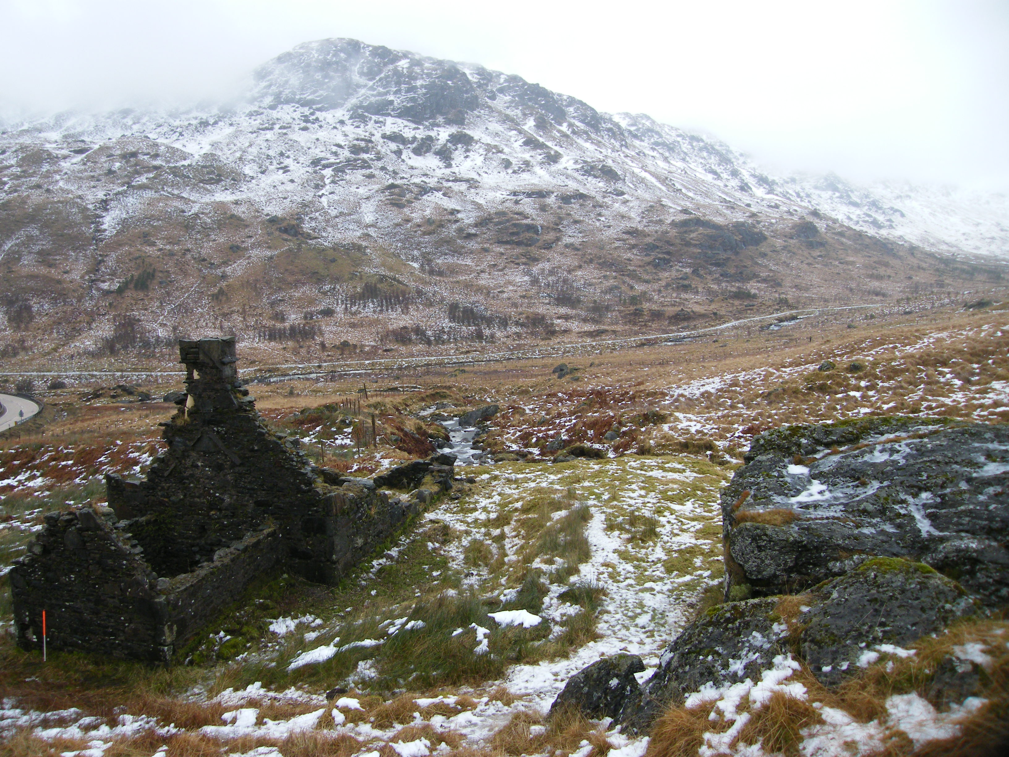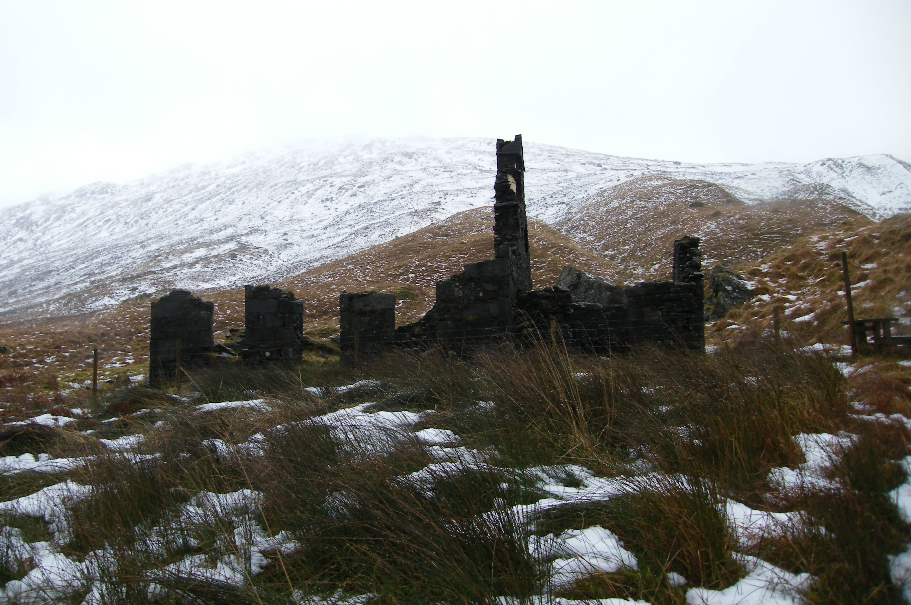

Plate 53 and 54 – Ben Ime House from SE (left) and main elevation to W (right).

As a ruined structure Ben Ime House is very instructive; it allows a close inspection of the details of the construction of what is fairly typical of many of the other buildings of the 19th century improvement period on the Ardkinglas estate. The house is north/south aligned with a principal frontage facing down the glen to the west. It is of typical three bay, 1½ storied arrangement, with a central entrance and windows on either side on the principal frontage. There is a smaller jamb (wing) attached to the centre of the south gable wall.

The south gable wall of the main cottage still stands to its full height including its chimney. Much of the gable wall of the south jamb also still stands, though not quite to its full height. Walls generally survive to their wall heads, particularly on the west (entrance) elevation. The jamb is also more or less complete to the wall head as is the southern third of the east wall of the main house. The northern two thirds of the main house are now reduced to about 1m - 0.5m above original ground surface. The northern gable wall has fallen and its remnants do not get much above 1m in height.

Internally the jamb is without particular features other than to the southeast corner where there is an opening for a flue that rises up diagonally within the small gable wall, and a group of stones below that may be the base of a pot-boiler - ? a wash house. The threshold stone to the jamb is still visible, formed of a single squared block of schist.

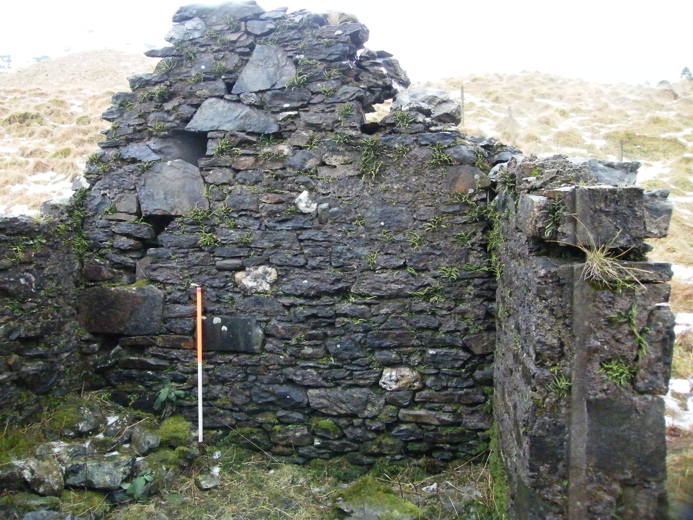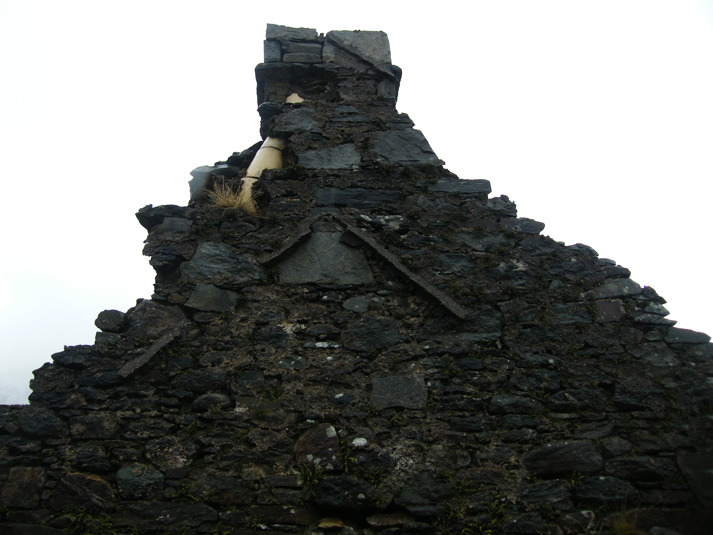

Plate 57 and 58 – Southern gable of extension and imprint of the roofline of the extension on main gable wall and the fillet of cement above, indicating the overhanging roof of the main building.

On the exterior side of the chimney that is the south side of the surviving gable wall of the main house there is a diagonal fillet of cement where a roofline had run in - considerably above the fillet of the roofline of the jamb. This appears curious but it clearly indicates that the main cottage roof had extended over the eaves and the gable wall heads and had extended around the chimney itself, a feature that is seen on other houses on the estate. This is simply where that part of the roof ran onto the exterior.

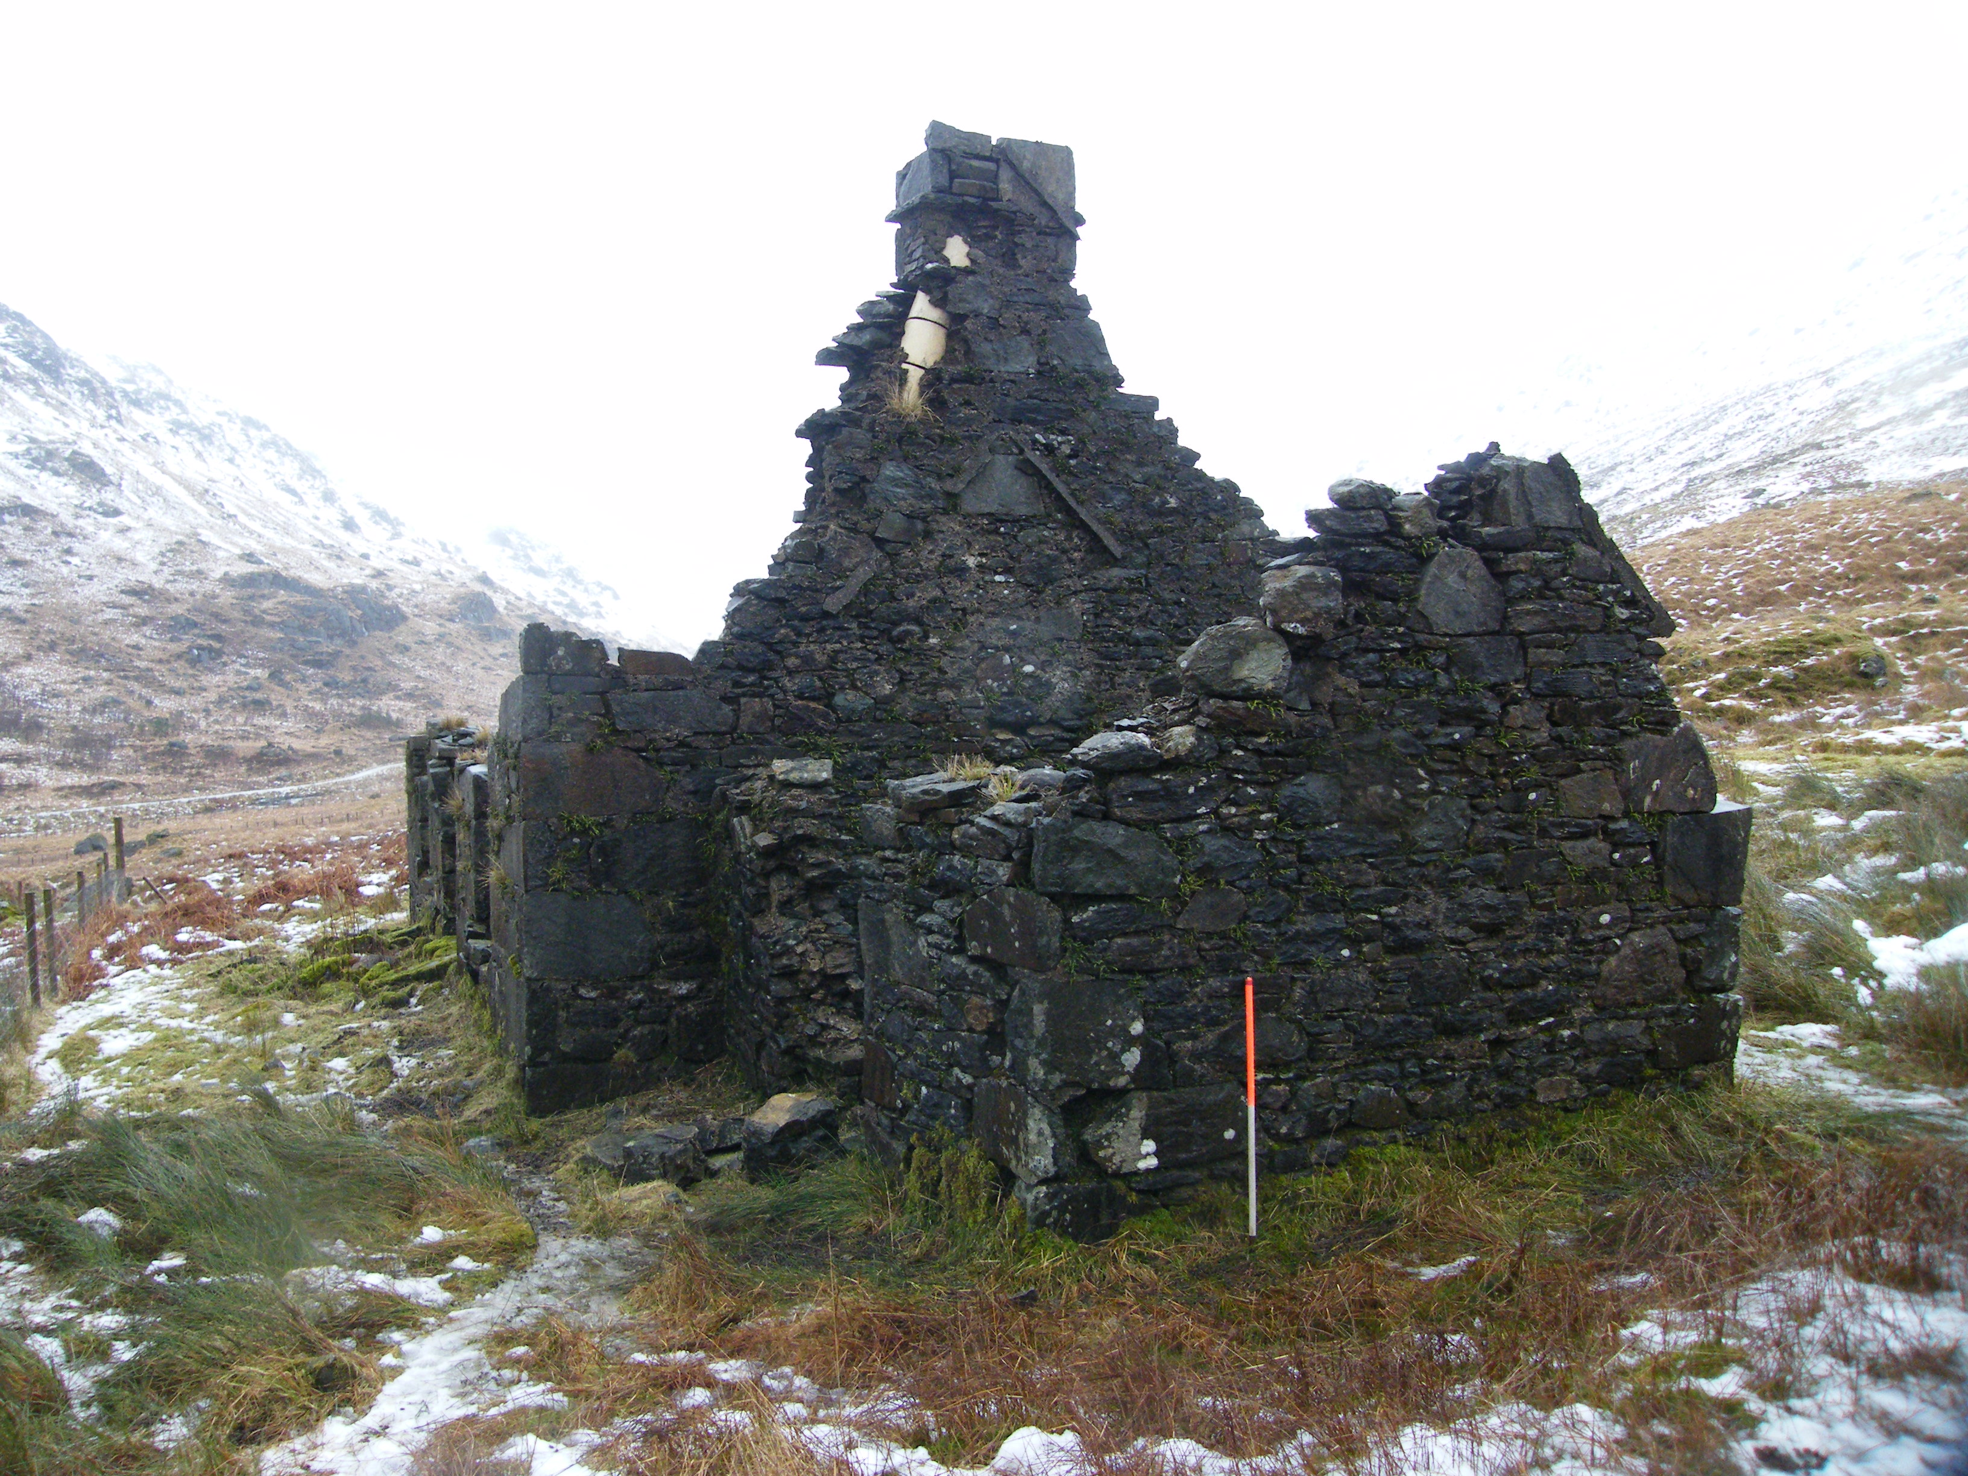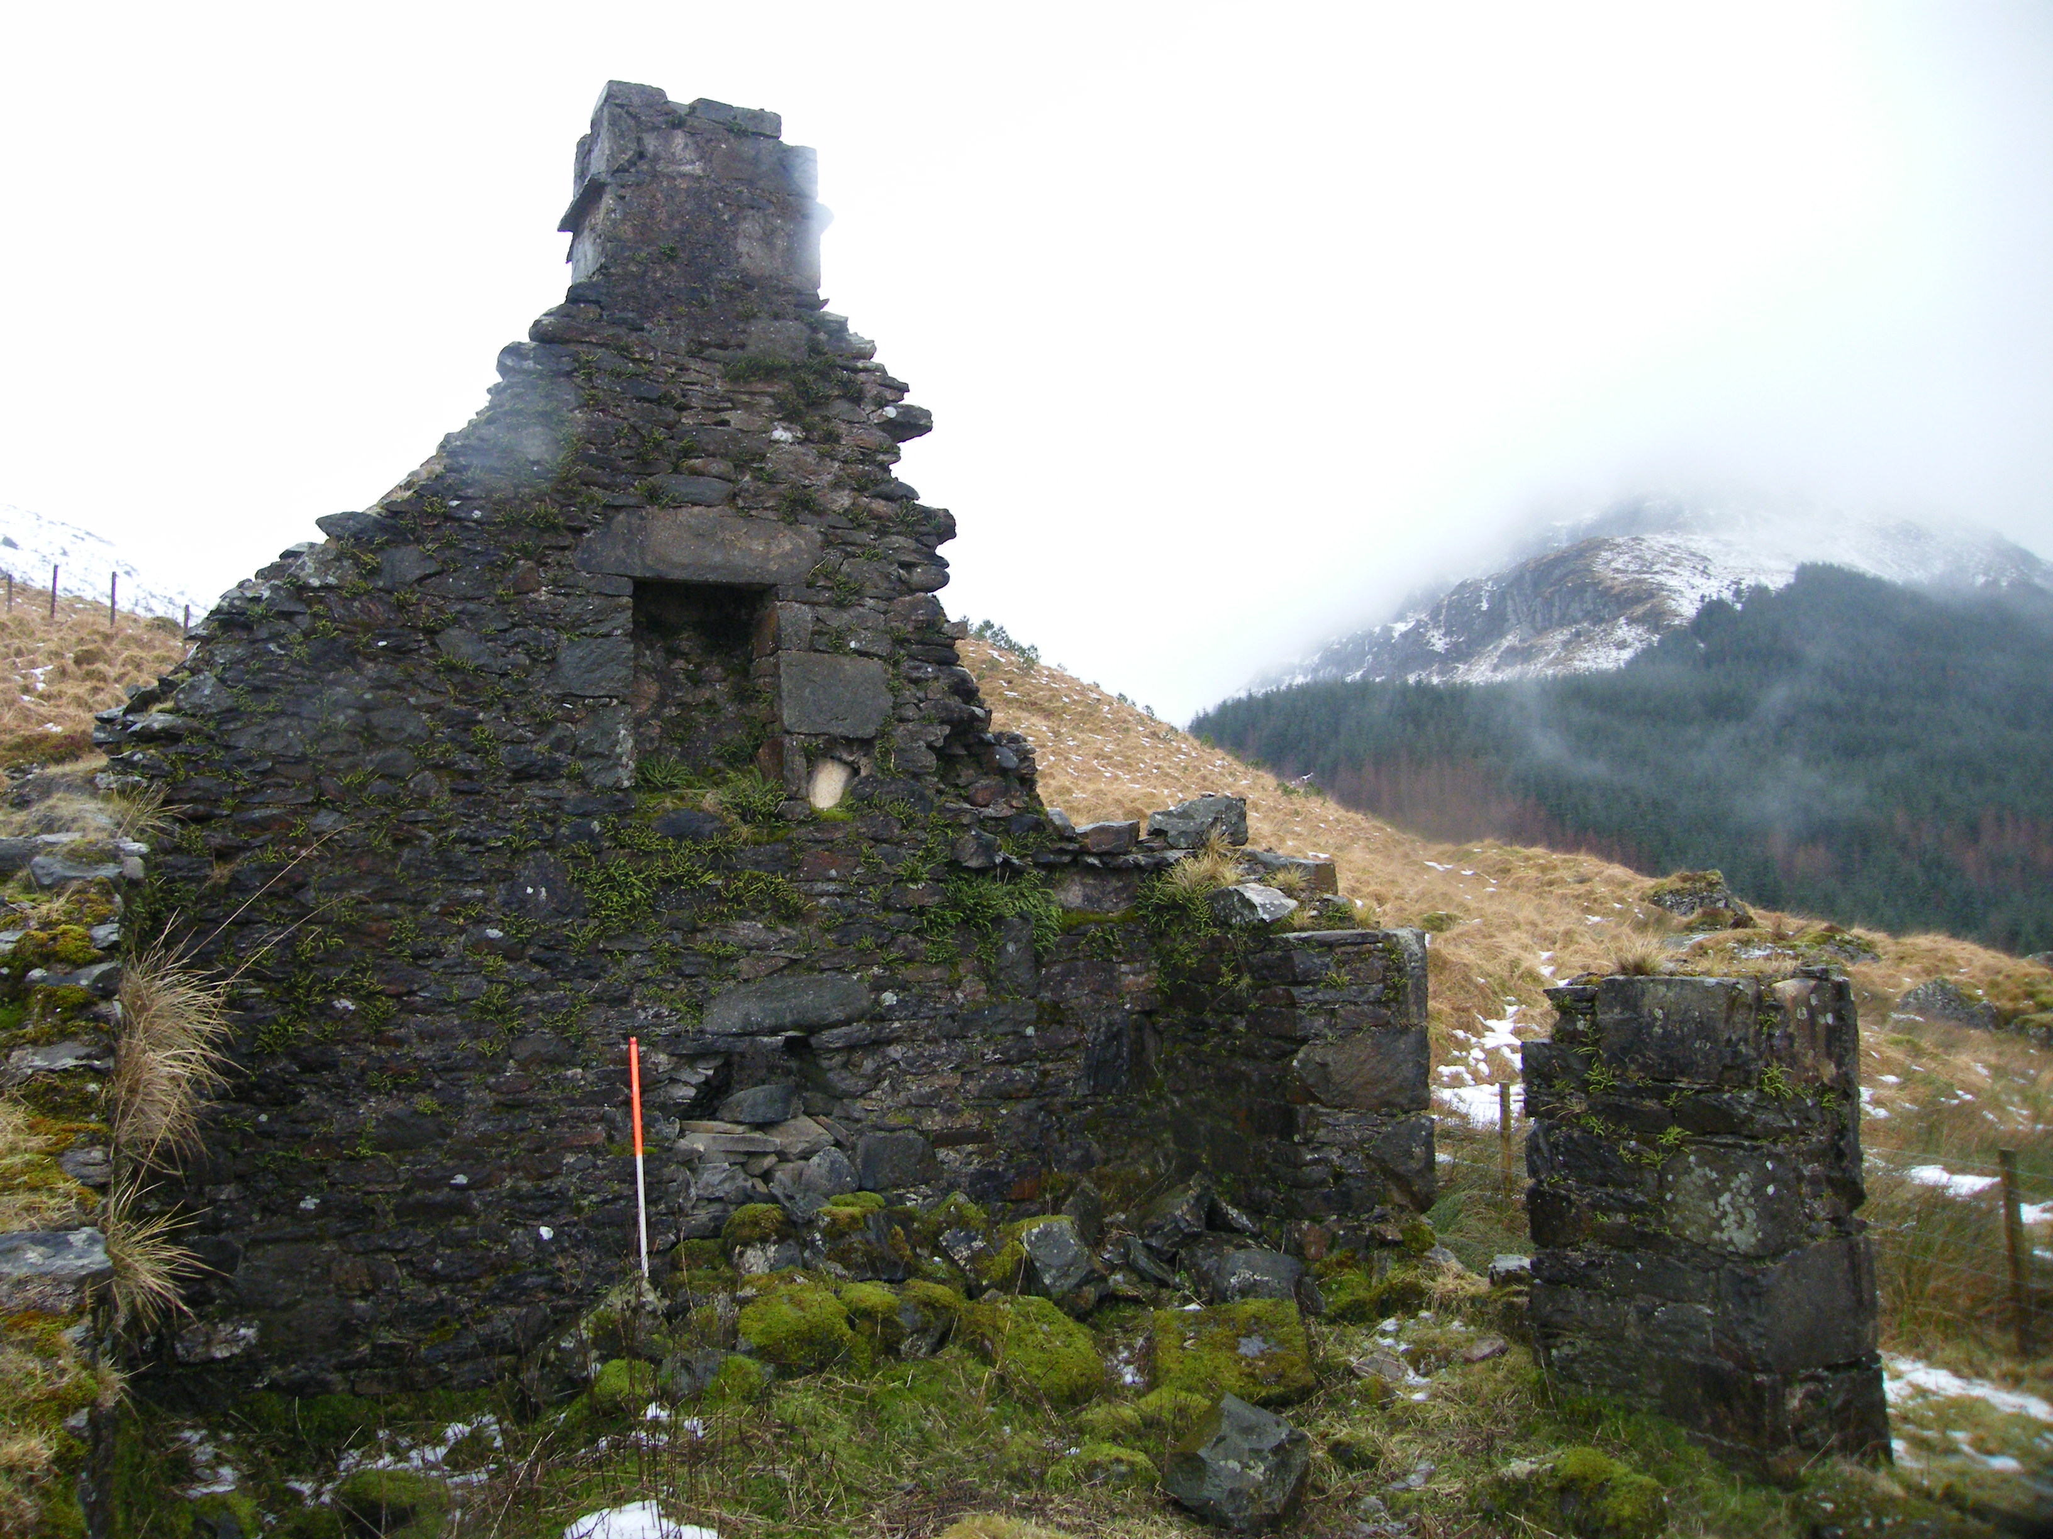

Plate 55 and 56 – Southern extension (from outside) and southern gable of main house (from inside).

The structure is rubble-built, mortar-bonded throughout, employing local stones and schist. Quoins at the corners are formed of very large slabs of whin that have seen some coarse dressing in order to square off the angle. The other openings within the structure, the windows, fireplaces and so on, are similarly formed up of larger, angular blocks of the same whinstone. Occasionally at the angles it displays some coarse dressing. Externally there are some traces of pointing and apparently some areas where there has been secondary cement pointing as well. The building seems to have been fairly flush pointed originally. The walls are very rectilinear and regular.

This cottage had likely been of similar plan to many others on the estate with a small entrance vestibule behind the central entrance and a straight stair to the rooms on the upper level. There were larger ground floor rooms on either side of the stair accessed to the north and south just within the entrance. The interior at ground floor is choked with masonry 1m or so deep – the collapsed rubble from the surrounding walls. However, in the north and south walls, central to each, are the remains of fireplaces. The lintel to the one to the north is still there, dislodged. The fireplace to the south - the back of that has been broken through into the adjoining compartment. Within the two main frontage rooms there are wall presses and these are at the north-west and south-west angles within the respective gable walls. There are few other surviving details other than the last remnants of a window opening, almost central to the up-slope wall to the east. This may have been a small window for an under-stair space (which is also seen at a number of other cottages surveyed).

At the upper floor little now remains other than what is visible in the surviving south gable. There is a central fireplace that is still well preserved and the chimney above this is intact with its projecting thackstone still clearly visible and part of the masonry above still surviving. Splitting of the west side of the gable wall has revealed the flue of the ground floor fireplace, this was formed of sections of a cream ceramic pipe. These are original to the construction of the building and were the flue-lining system - this would reinforce the dating of the structure to the mid-19th century. Otherwise there are few diagnostic details other than the regularity of the building, its proportions and its similarity to many others at Cairndow.

The small jamb to the south abuts the main building and is probably closely contemporary with it. It is similarly built of rubble stone that is often somewhat smaller than the main house. There is a central entrance to the west and partly ruined, particularly on its side where there has been a recent collapse. Quoins and the angles at the entrance are similarly of rough hewn angular blocks of whin. The south gable wall is leaning outwards and there is some cracking evident particularly to the south-west. The roofline of the structure is still preserved by a cement fillet against the gable wall of the main house.

